Office of the Department Commander
Mark R. Day
104 Mullbury Place
Lynchburg, VA 24502
oscmbb64@msn.com
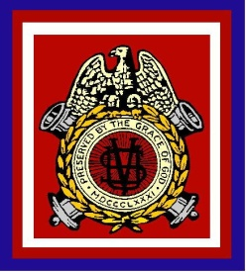
General Order #7
SERIES 2013-2014
April 26, 2014

Brothers of the Department of the Chesapeake,
As, I take leave of the office of Commander please let me express my sincere appreciation for the support you have given me over the past year. Being Commander of the Department of the Chesapeake has been one of the most rewarding experiences of my life.
Now in this final hour of my administration, I issue this order to document the following personal awards that were presented at the 127th Department Encampment in Lynchburg, VA.
The Richard C. Schlenker Award for Merit [The Department of the Chesapeake's Highest Award] - Brother Ben Hawley, Lincoln Cushing Camp
The Andrew Johnson Medal for Service to the Department of the Chesapeake Brother Karl Woodcock, Antietam Camp Brother Brian Withrow, Irish Brigade Camp
The Dr. Mary Walker Award [Ladies Appreciation, Department Award] Sister Mildred Ames, Lincoln Cushing Auxiliary
Mark R. Day
Commander, Department of the Chesapeake
Sons of Union Veterans of the Civil War

Attest:
Michael Paquette
Secretary, Department of the Chesapeake
Sons of Union Veterans of the Civil War

