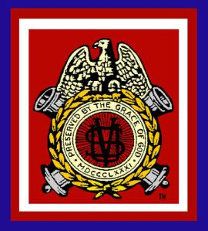
DEPARTMENT OF THE CHESAPEAKE
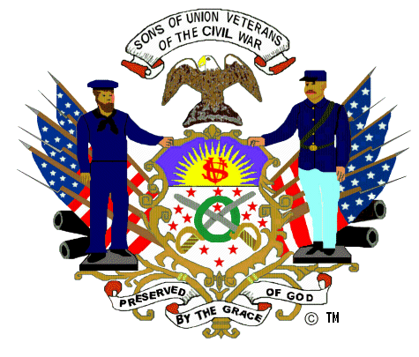
THE CHESAPEAKE GAZETTE
Winter, 2021-2022

U.S. Grant Bicentennial Week 2022

This year marks the 200th anniversary of the birth of Lt. General Ulysses S. Grant. He was born in Point Pleasant, Ohio, on April 27, 1822. In observance of this special time, the Department of the Chesapeake has developed the “U.S. Grant Bicentennial Week” to celebrate General Grant and his service to preserve the Union. As General-in-Chief, Grant coordinated the Union efforts in the field, which brought about the end of the war.
The Grant Bicentennial Week begins in conjunction with the Department Encampment, at The Wilderness on Friday, April 22, at 3 pm. On Sunday, April 24, at 12:00 pm, a brief observance will be conducted at the U.S. Grant Monument, in Washington, DC. The next event will occur on General Grant’s birthday at the Appomattox Court House National Historical Park, Wednesday, April 27, at 1 pm. Our observance of the Grant Bicentennial Week will conclude at City Point, on Saturday, April 30, from 11:00 am to 1:00 pm.
Special thanks to Department Commander Leturno and Camp Commanders Mark Day, Howard Bartholf, and Tim Willging, for their efforts.
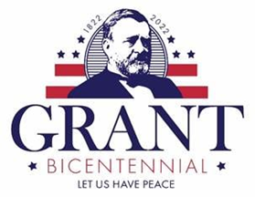
From the Editor in Chief/Senior Vice Commander
Brian W. Horgan, DSVC

It is hard to believe that this is my final edition as Editor of The Gazette. It feels as if I published my first edition just the other day. The past year has gone quickly and I have enjoyed the opportunity to gather the news from around the Department and share it with all my Chesapeake brothers. In the process, I have also discovered the scope of our work and the passion with which our brothers fulfill our mission.
Over the last year, we have worked at the Department level, as well as throughout the region, at the camp level, to remember the service of our ancestors who sacrificed to save the Union. I admire Commander Leturno’s commitment and dedication on every level and in regards to every project. Likewise, I am proud of our efforts in our communities, working to preserve historic cemeteries, conducting educational programs, coordinating Memorial Day observances, and fostering recognition for JROTC/ROTC students as well as Eagle Scouts. In addition, we have participated in battlefield preservation efforts and various ceremonies and events. We have also led the way in keeping green the memory of our Union heroes for the Congressional military base re-naming program.
While this is my last edition, I encourage you to share your valuable work in future editions of The Gazette. The work you do may provide an example for other brothers throughout the Department. Submissions and the next quarterly reports should be consolidated at the camp level by Camp Senior Vice Commanders, submitted as a Word document or email, and forwarded to the next Department Senior Vice Commander. The deadline will likely be the end of July.
From the Department Commander’s Desk

Brothers,

I hope this finds you and your families well. It’s not so easy to reach out and ask that question. Thanks to Brothers Brian Horgan and Mark Day we have venues to communicate thoughts, like the Chesapeake Gazette and Department website, that offer wide distribution. I use this issue to share some final thoughts.

I’ve had the privilege of visiting virtually and physically many of our Camps. Observation. Meeting frequency, membership size and activity levels vary. There is a core of Brothers that attend most meetings. By default, these are the Camps elected/appointed officers and without them we would fail. Sadly, these Brothers serve as officers year after year while others never serve. True, experience maintains continuity, but change promotes growth. A Camp needs the Commander for leadership and vision. A Camp must have a dedicated Secretary/Treasurer to survive. To Brothers who have never served their Camp, I ask that you step up. Your Camp needs you, the Order needs you.

The Department Encampment is 22-23 April 2022 in Fredericksburg, VA. The 22nd includes tours of local battlefields and the first of four Ulysses S. Grant Bicentennial events. The 23rd includes Department business and officer elections. Our luncheon speaker is NMPS Senior Historian (Retired) John Hennessy. I sincerely hope to see you there. Please make your reservations by April 8th. Contact Department Secretary/Treasurer, D. Michael Beard, if you need a registration form.
We are now in the season for ROTC presentations. Contact your schools with ROTC/JROTC programs and ask them to participate. This program costs the Camps nothing. Just send me your schoobb award requests and I can either mail the award or bring them to the Encampment for distribution.

Finally, an update on the Naming Commission’s activities. The Commission received over 34,000 recommendations to rename Army installations named after Confederates. They narrowed the list to 90 for serious consideration. One of the 90, William Carney, was submitted by the Department of the Chesapeake. A final list of recommendations will be submitted to Congress 1 Oct 2022. Thanks to everyone that assisted, I can proudly say we got the Commission’s attention.

Once again, the 135th Department of the Chesapeake Encampment is April 22-23, 2022, in Fredericksburg, VA. See you there.

Yours in Fraternity, Charity, and Loyalty,
Roger Leturno, DC
Commander
Department of the Chesapeake
Sons of Union Veterans of the Civil War

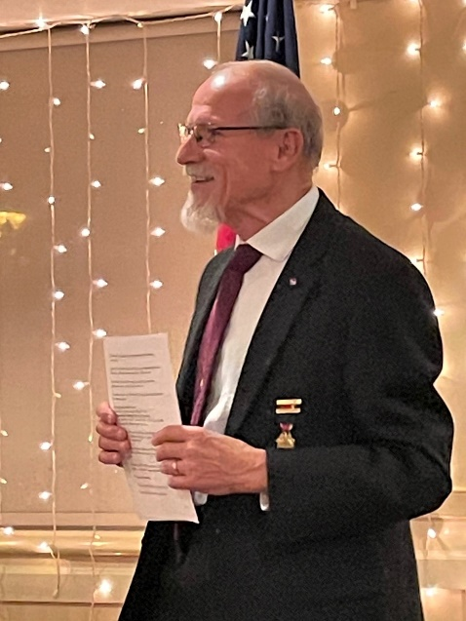

Patriotic Instruction – April 2022

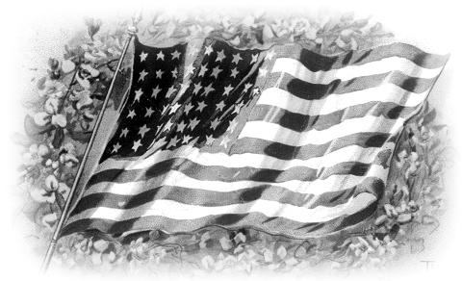

What is a Warrior?

Recently, on March 29th, we observed “Vietnam Veterans Day” in the United States. This particular day is set aside to remember, and recognize, all the U.S. troops who served during the Vietnam conflict. What most Americans, and even many current and former military members don’t know, is that it does not recognize just those military members who served “in-country” in Vietnam, but rather ALL the U.S. Military members known as “Vietnam Era Veterans,” who served anywhere in the world during, what is officially known as the “VIETNAM ERA, “(period from August 6, 1964 until May 7, 1975).”

It has been the same in almost every war ever fought. There is a percentage of the military sent to “The Front” to fight, sometimes hand-to-hand with the enemy, but there is a far greater number who serve close behind, or far in the rear, in important roles which enable the frontline warriors to operate efficiently, and effectively. Often times these “rear-echelon” personnel get overrun, bombed, killed by landmines, die on death marches, become prisoners of war, and/or suffer and die from the same diseases that everyone else endures. And yet, they don’t get the respect due to them. They are however, patriots, just as if they had gone forward into the “heat of battle.”

Supply, logistics, transportation, communications, medivacs, doctors, nurses, and many others.

“Behind the lines,” work hard to support the overall mission in each and every conflict. It was no different during the U.S. Civil War, as author William Davis once wrote about the 1863 U.S. Veteran Reserve Corps:

“The enormous manpower demands of the Union Army’s many functions behind the lines became so great that Washington had to attempt to place less able-bodied men in some postings, in order to free the fitter men for active service. Thus in 1863 was created the Veteran Reserve Corps. It was to be composed of men who were disabled or hospitalized and divided into two battalions – one for men able to use weapons, the other for those missing a limb. Eventually, veterans whose terms of enlistments had expired were also allowed to serve in the corps, with or without disabilities. Men of the reserve wore uniforms of sky-blue kersey, with dark blue cap and trimmings, the jacket cut short in the cavalry pattern, even though they were strictly an infantry service. Their weapons were usually old or worn-out models, which like their owners were no longer needed on the front line.” (1)

As we enter April 2022, and pause to recall the attack on Fort Sumpter on April 12, 1861, let us never forget our Patriotic Duty as Brothers to remember, and recognize, ALL who have served, and are continuing to serve around the world, whether they be active duty, veterans, or patriotic civilians. They are all “warriors” in their own right. Keep them ALL in your hearts and prayers.

FC&L,
Andrew W. Johnson, M.Ed.
Patriotic Instructor
Department of the Chesapeake
Sons of Union Veterans of the Civil War

Camp Updates

The “Camp Update” section shares activities of our Brother camps. These updates are intended to provide information of the various ways in which our Brothers serve to honor “the Boys in Blue”.

James A. Garfield Camp #1

On January 15, 2022, the Camp’s officers conducted a virtual meeting to discuss plans for calendar year 2022. Specific topics discussed included details of the Lincoln Dinner, scheduled for early April, and the Memorial Day program.

On February 19, 2022, the Camp conducted a virtual meeting. Key topics discussed included:

The Camp approved a $400.00 donation to the American Battlefield Trust, presented to the Trust at the Lincoln Dinner.

The Camp approved a $250.00 donation to the Shenandoah Valley Battlefields Foundation in honor of the late Brother Stuart Smith. The donation will be funded by the Stuart Smith Memorial Fund.

On April 7, 2022, the Camp held its annual Lincoln Dinner at the Maryland Club, in Baltimore. Mr. Charles Mitchell, author of “The Civil War in Maryland Reconsidered”, served as the guest speaker.

The Camp will participate in a grave marker dedication ceremony for African-American Union veterans at the historic Ellsworth Cemetery near Westminster, MD, on June 11, 2022.

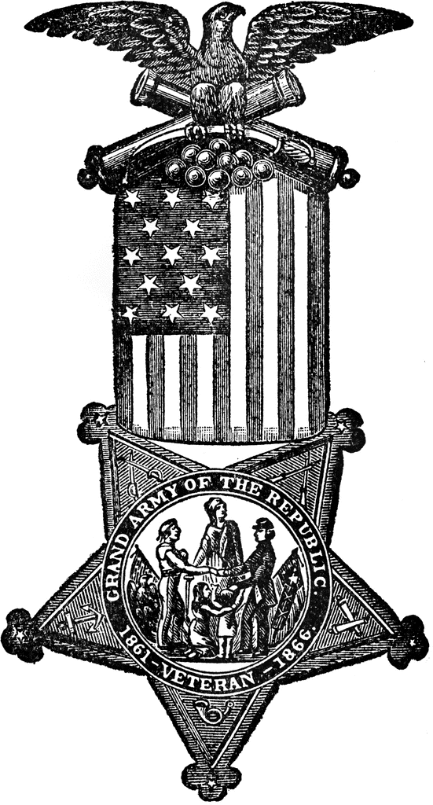

Appomattox Camp #2

On February 24, 2022, Commander Leturno visited Appomattox Camp 2 in Wilmington, Delaware at their monthly meeting in their new camp meeting room in the historic Mt. Salem Church. The current church, built in 1879, was the parish church for Frank P. Gentieu, Appomattox’s first Camp Commander in 1898. Pierre Gentieu, the family’s patriarch, a Civil War veteran, and GAR member, is buried in the church cemetery along with 89 other Civil War veterans.

Commander Leturno was introduced by Camp Commander George McDowell and briefed the camp on the Department’s current work. Commander Leturno was also introduced to Brother James Flaherty and Tom Kenny who briefed everyone on the Wilmington Memorial Day parade, the longest consecutive Memorial Day in the United States, the same parade organized by Frank Gentieu for 28 years.

In addition to the enjoyment of good fellowship, Commander Leturno was briefed on the Camp’s work on identification and biographies of local GAR cemetery veterans and viewed historic camp memorabilia on display including Pierre Gentieu’s GAR medal and Civil War-era trumpet.

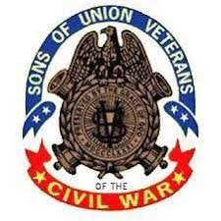

Lincoln-Cushing Camp #2

During the Winter Quarter, Lincoln-Cushing Camp No. 2 held two Camp meetings. The meeting on December 4, 2021, at McGinty’s in Silver Spring, MD., was our first in person meeting since the beginning of the pandemic. The Camp was honored to have Department Commander Roger Leturno in attendance to install the Camp’s newly election officers, who were Commander Eric Atkisson, Camp Senior Vice Commander Kent Boese, Camp Junior Vice Commander Marc Rajotte, Secretary/Tresurer Karl Garman and the Camp Council, Charlie Bogino, Lee Stone, and Steve Bohling. At the December meeting we also inducted six new Brothers, Derek Dufresne, Matt Phillips, David Crist, Mark Herbert, Kevin Eichelberger and Tony Wickham.

The first Camp meeting of 2022 was held on March 19 at Cedar Knoll in Alexandria, VA. Highlights of the meeting included Department Commander Roger Leturno, who discussed our Department encampment on April 22 and 23, and our guest speaker Mr. Frank O'Reilly, who presented some little-known facts and background on the Battle of Fredericksburg. We also inducted our newest Brother Craig Bucher.

Other highlights during this quarter include:
• On January 15, the Camp Officers held their meeting at the George Washington Masonic National Memorial, which included a tour of the memorial following the meeting.
• Brothers Eric Atkisson and Lee Stone provided support to the Lincoln birthday ceremony at the Lincoln Memorial on February 12. Brother Lee laid a wreath for the Sons of Veterans Reserve during the ceremony.
• On February 19 Brothers Eric Atkisson, T. J. Bradley, and Dave Welker paid a visit to the Mount Carmel Church in Ashby's Gap to plant flags at the grave of 1st Sgt. Philip Paul of the 14th Pennsylvania Cavalry. Brother T. J. explained the history of the action near the church in February 1865 in which several Union soldiers, including Paul, were killed during an ambush by Mosby's 43rd Virginia Cavalry Battalion and buried in the church cemetery. 1st Sgt. Paul.'s headstone was installed several years ago thanks to the diligent efforts of his great-grand-nephew Brother Craig Ross and several other camp members.
• On March 9 Commander Eric Atkisson toured the new site of the African-American Civil War Museum which is under construction across the street from the African-American Civil War Memorial in Washington, DC.

Sgt. James H. Harris Camp #38

The Sgt. James H. Harris Camp has been getting a bit busier in the past few months. On November 13th, the Camp conducted our annual USS Tulip Monument Commemoration Ceremony in Saint Inigoes, MD. The ceremony was well attended by the public and we were honored to host the Department Commander, Roger Leturno.
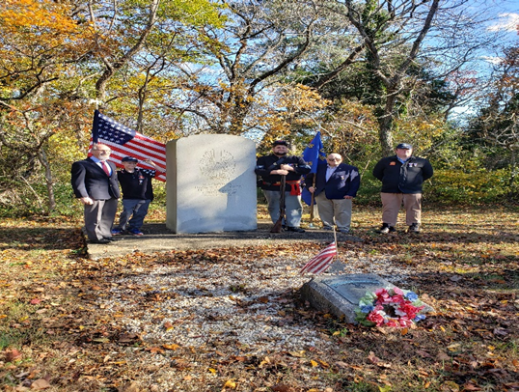

On multiple occasions in November and December, Brother of the Camp helped with other organizations to do clean up of the Galilee Church cemetery with has several USCT’s buried in it. All but one are currently unmarked. In March, clean up operations commenced again and Brothers are helping.

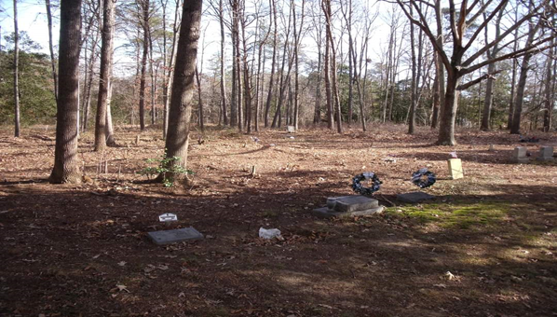

In January, we were forced to postpone our Camp Luncheon due to Covid-19 Omicron concerns and as such conducted a Zoom Camp installation on February 11th. We were again honored to have Department Commander Roger Leturno as our installing officer. The following Brothers, were elected, or appointed, to the following positions:

CC: Joshua Hughes; SVC: Wes Mumper, PCC; JVC: Karl Pence; S/T: Chuck Gantz; Camp Council: #1 David Roberts, #2 Bert Stevenson, #3 Wes Mumper; PI: Wes Mumper; Chaplain: Bert Stevenson; Historian: David Roberts; Guard: Jimmy Mumper; Guide: Mike Mumper; Color Bearer: Jimmy Mumper; Graves Registration: David Roberts; CW Monuments & Memorials: Joshua Hughes; Eagle Scout Coordinator: Wes Mumper; ROTC/JROTC Award Coordinator: Wes Mumper; Counselor: Wes Mumper.

On March 11th, CC Josh Hughes and CSVC Wes Mumper, PCC, got together to initiate a new member, Andrew Hance. Andrew is a US Army Veteran and a native of Calvert County. He is a decedent of a soldier of Co. H of the 1st MD Eastern Shore. He has a great passion for history and is also a member of the SAR. We are truly honored to have him.

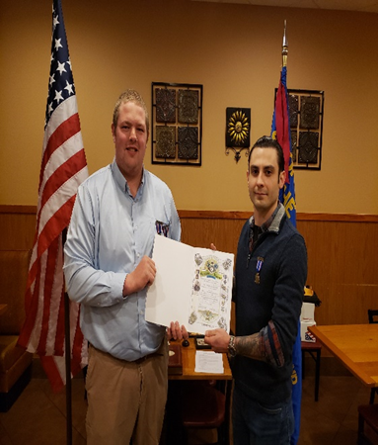

Additional Camp Notes

Irish Brigade Camp #4 – Camp Commander Tim Willging has worked closely with the National Park Service to host the opening event of the Grant Bicentennial Week, at The Wilderness, on Friday afternoon, April 22, 2022.
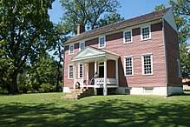

Taylor-Wilson Camp # 10 – Under the leadership of Camp Commander Mark Day, PCinC, the camp has been working with Appomattox Court House National Historical Park to host a Grant Bicentennial observance on the 200th Birthday of General Grant, April 27, 2022.
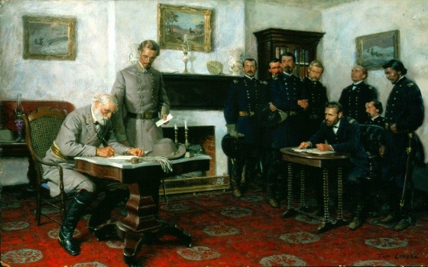

Col. James D. Brady Camp #63 – The Brady Camp is working hard on its JROTC/ROTC program and looks forward to participating in numerous school programs this Spring.

Army of the James Camp #1864 – Camp Commander Howard Bartholf has been working with the National Park Service to host a Grant Bicentennial program at City Point, on Saturday, April 30, 2022.
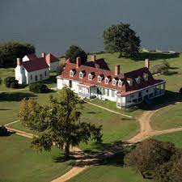
Upcoming Events

This section of The Chesapeake Gazette is dedicated to upcoming activities within the Department and sponsored by the Camps. Camp commanders and SVCs, please submit your calendar of events for the next quarter with your quarterly report for inclusion here. In addition, you can send your updates to Department Signals Officer Mark Day, PCinC at: OSCMBB64@msn.com, for inclusion on the Department webpage.

135th Encampment of The Department of the Chesapeake

FRIDAY ACTIVITIES

10 AM – 1:00 PM Special guided tour of Spotsylvania
and Wilderness Battlefields

3:00-3:30 PM Ulysses S. Grant Bi-Centennial Event
Ellwood Manor, 36380 Constitution Highway
(Route 20) Locust Grove, VA

4:00 PM – 6:00 PM Early Arrival - Encampment Registration, Sign-In

6:30 PM Group Dinner: Park Lane Tavern, 1 Towne Center
Blvd, Suite 4100, Fredericksburg, VA Virginia
SATURDAY’S SCHEDULE (tentative)

Registration: 7 - 8:00 AM

Joint Service: 8:00 AM

AM Session: 8:45 AM

Joint Luncheon: 12:00 Noon – Department Awards and special presentation by John Hennessy
PM Session: 1:30 PM

Visits: By ASUVCW 1:45 PM

Visits: By SUVCW 2:15 PM

Group Photos: 5:00 PM
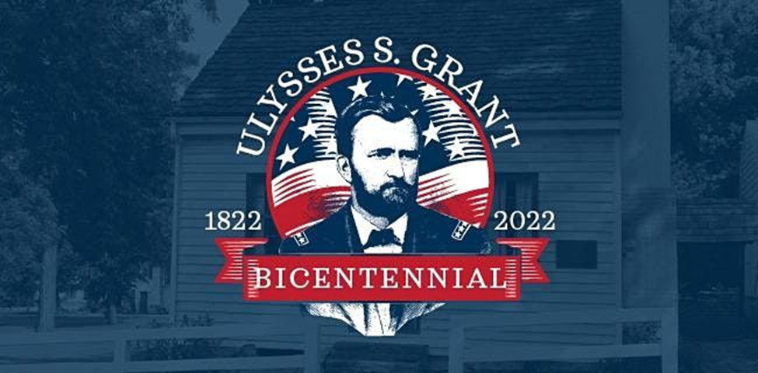

Sons of Union Veterans of the Civil War
DEPARTMENT OF THE CHESAPEAKE
“U.S. Grant Bicentennial Week”

To honor General-in-Chief Ulysses S. Grant and his service to preserve
the Union on the occasion of the 200th anniversary of his birth.

Friday, April 22, 2022
Ellwood Manor
Wilderness Battlefield, Fredericksburg and Spotsylvania National Military Park, VA
3:00 PM

Sunday, April 24, 2022
U.S. Grant Monument
U.S. Capitol (West Front), Washington, D.C.
12:00 -12:30 PM

Wednesday, April 27, 2022
McLean House
Appomattox Court House National Historical Park, VA
1:00 PM

Saturday, April 30, 2022
Petersburg National Battlefield, VA
General Grant’s Headquarters Unit/Appomattox Plantation
11:00 AM – 1:00 PM
2021-2022 Department of the Chesapeake Officers

Commander - Roger Leturno, DC

Senior Vice Commander - Brian Horgan, DSVC

Junior Vice Commander - Tommy Chapman, DJVC

Secretary-Treasurer – D. Michael Beard, PDC

Council - Faron Taylor, PDC, Jay Rarick, PDC, Timothy McCoy, PDC

Chief of Staff – Timothy Alghrim, CC

Patriotic Instructor – Andrew Johnson, PCC

Chaplain - Dr. Clifton Potter, PCC

Signals Officer - Mark Day, PCinC

Assistant Treasurer - Larry Vance

ROTC Coordinator - Roger Leturno, DC

Civil War Memorials Officer – Jay Rarick, PDC

Eagle Scout Coordinator - Robert Stine, PCC

Graves Registration - Steve Hammond, PDC

Guide and Guard – Howard Bartholf, CC

Color Bearer - Robert Heath, PCC

