Office of the Department Commander
Mark R. Day
104 Mullbury Place
Lynchburg, VA 24502
oscmbb64@msn.com
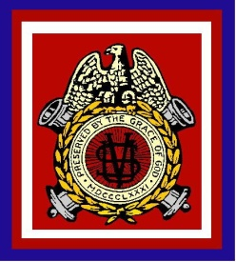
General Order #2A
SERIES 2013-2014
July 25, 2013

Brothers of the Department of the Chesapeake,
After some discussion, it was felt that the second Paragraph of Department General Order #2 should be revised to more clearly explain the intentions of the Department Commander in forming a committee on hosting the 2015 National Encampment of the Sons of Union Veterans.
The original second paragraph gave the impression that the Department of the Chesapeake had already been selected as the 2015 encampment host, which is not in fact correct and was not the intent of the Department Commander to portray. This committee is being created to give the department a leg-up on planning and preparations should it be selected.
The second paragraph of General Order #2 should now read as follows:
Should the Department of the Chesapeake be selected as the host Department, for the 2015 National Encampment by the National Encampment Committee, the primary duties of this new special committee will be to work with the National Committee on Encampments to provide planning and execution for the 2015 National Encampment of the Sons of Union Veterans of the Civil War, which would be held in Richmond Virginia. The assignments and duties of individuals will be at the discretion of the Committee Chairman.
Ordered this 25th Day of July, 2013.
Mark R. Day
Commander, Department of the Chesapeake
Sons of Union Veterans of the Civil War

Attest:
Michael Paquette
Secretary, Department of the Chesapeake
Sons of Union Veterans of the Civil War

